**Preparation of Papers for The 13th BENJAMIT Network National & International Conference**

**Title**<12 point, Bold>

**Author’s Full Name (**e.g. **First Name Last Name1, First Name Last Name2 and**

**First Name Last Name3)**<11 point, Bold>

1Full Address (Department, Faculty, University, City, Postal Code, Country)<11 point, Normal>

2 Full Address (Department, Faculty, University, City, Postal Code, Country)

3 Full Address (Department, Faculty, University, City, Postal Code, Country)

**Abstract**

The instructions below are specially directed at author(s) who wish to submit a manuscript to Knowledge Integration to Sustainable Development. The manuscript must be clear and its format must be consistent with the other papers included in the conference CD-ROM proceedings. Use this document as a template if you are using Microsoft Word 2010. Otherwise, use this document as an instruction set.

***Keywords****:* Two to four keywords should be provided here to assist with indexing of the article.

**Background and Statement of the problem**

(It is a description of the history of research problems that make researchers Interested in doing this research) This document is prepared as a guide to writing the full article by defining both forms and guidelines for printing articles. Which is the same format that is used in the preparation of meeting documents both in CD form. After the article was considered by the committee, consider the article to be presented at the meeting. Article senders must prepare and submit complete articles in the form of "PDF File" and "Word File". In order to make the document as standard the person who submitted the article should type the article in strict accordance with the format and guidelines.

The full article should include the title of the article, name and address of the author, abstract, key words, complete content of the article, acknowledgment and reference documents. By the content of the article can be divided into main topics, sub-topics and may be divided into sub-topics. All letters used in every section are typed using the Time New Roman font. The distance between the lines is single line and each page does not have to fill in the page number.

The size of the paper used in printing is set to A4 standard size (8¼ 11¾ inches. By the other parts of article except the title of the article, name and address of the author, abstract and keywords, typing by setting the page settings as follows

Top edge of the paper 25 mm.

Bottom edge of the paper 20 mm.

Left edge of the paper 25 mm.

Right edge of the paper 20 mm.

The overall length of the article should be in the range of 8 - 12 pages of paper.

Putting references such as learning can always be learned [1], so we can continue to develop.

**Objective**

**(Specify the purpose of doing this research)**

**Expected benefits**

**(Identify what has been done in this research)**

**Conceptual Framework**

**(Specify the conceptual framework of the research and the theory Concepts used to create conceptual frameworks and assumptions (if any))**

**Research Methodology**

(Specify the details of the population ,Sample, Sample group selection, sample size, data collection variable) .The content of the article must be typed in a 1 column format according to the specified size and distance. The characters used in the content are 11 points. And the typing pattern is aligned on both sides, including no line spacing between paragraphs.

**Research Results**

(Report of findings according to the sequence of research clearly and according to the objectives of the research and assumptions (if any) if the findings there are many numbers or variables) should use tables or charts instead. Presentation of pictures and tables can be presented from the message mentioned or may be presented after the end of the topic or presented on the new page.

Both images and tables must have an explanation. By the description of the image, type it under the picture and centered on the page. If any image is divided into 2 parts, the description of each part will be specified by using English in brackets, in order such as (a) and (b). As for the table description, type above the table and align the left edge of the column or align the left edge of the paper by sorting pictures and tables to separate the order from each other.

Specifying the sequence number, picture and table in the article, specify as picture 1 or table 1, etc.

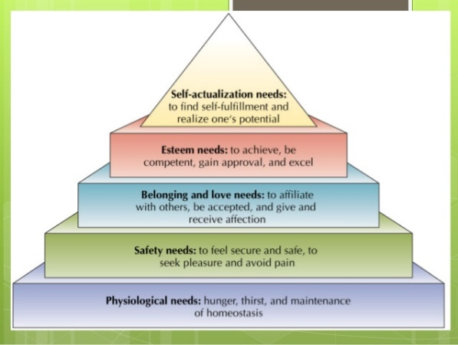

Figure 1 Maslow's motivation theory [1]

Table 1 shows the average standard deviation and the level of opinion, the results of operations in the Active Learning teaching and learning management

|  |  |  |  |
| --- | --- | --- | --- |
| Evaluation list | Evaluation | | |
|  |  | Results |
| 1. System Evaluation  2. Evaluation of program preparation  3. Evaluation of program implementation  4. Evaluation for program improvement  5. Evaluation for program certification | 4.80  4.48  4.44  1.38  4.50 | 0.874  0.290  0.271  0.373  0.390 | high  Quite high  high  Low  high |

**Summary of the Study**

(This is a summary of the results of the study, only the important issues that are complete and suggest the research that will be used or questions for further research)

**Discussions**

(Discuss the findings with reliable references)

**Recommendations**

(Suggesting research that will be used or questions for further research)

**Acknowledgment**

If you want to write acknowledgments to thank the person or agency involved can write by staying behind the main content of the article and before the reference document (Optional)

**Reference**

[1] L. Stein, “Random patterns,” in *Computers and You*, J.S. Brake, Ed. New York: Wiley, 1994, pp. 55-70.

[2] J. K. Pink, “Article Title,” in Proc. *International Conference on Green Computing*, Paris, France, Jan. 2012, pp. 50-55.

[3] R. Good. (2011, Feb 10). *Computers* (2nd ed.) [Online]. Available: http://www.computers.com

[4] N. Kawasaki, “Parametric Study of Thermal and chemical nonequilibrium nozzle flow,” M.S.thesis, Dept. Electron. Eng., Osaka Univ., Osaka, Japan, 1993.

**Other details:**

Writing reference documents

To compile a list of publications and various knowledge materials used as evidence or reference documents in the study at the end of the article. By reference in the article, refer to by using numbers in square brackets such as [1], [1,2] or [1-3], etc., ordered according to the previous reference For printing forms, list of reference documents from various sources, have the format based on the IEEE Referencing Style as follows:

(https://ieee-dataport.org/sites/default/files/analysis/27/IEEE%20Citation%20Guidelines.pdf)

***Books***

[1] J.K. Author, “Title of chapter in the book,” in *Title of His Published Book*, xth ed. City of Publisher, Country if not USA: Abbrev. of Publisher, year, ch. x, sec. x, pp. xxx-xxx

[2] L. Stein, “Random patterns,” in *Computers and You*, J.S. Brake, Ed. New York: Wiley, 1994,   
pp. 55-70.

***Conference Technical Articles***

[3] J.K. Author, “Title of paper,” in *Unabbreviated Name of Conf.*, City of Conf., Abbrev. State (if given), year, pp. xxx-xxx

[4] J. K. Pink, “Article Title,” in Proc. *International Conference on Green Computing*, Paris, France, Jan. 2012, pp. 50-55.

***Website***

[5] J.K. Author. (year, month day). *Title* (Edition) [Type of medium]. Available: http://www.(URL)

[6] R. Good. (2011, Feb 10). *Computers* (2nd ed.) [Online]. Available: http://www.computers.com

***Thesis and Dissertations***

[7] J.K. Author, “Title of Thesis,” M.S. thesis, Abbrev. Dept., Abbrev. Univ., City of Univ., Abbrev. State, year.

[8] J.K. Author, “Title of dissertation,” Ph.D. dissertation, Abbrev. Dept., Abbrev.Univ., City of Univ., Abbrev. State, year.

[9] N. Kawasaki, “Parametric Study of Thermal and chemical nonequilibrium nozzle flow,” M.S.thesis, Dept. Electron. Eng., Osaka Univ., Osaka, Japan, 1993.

[10] J.O. Williams, “Narrow-band analyzer,” Ph.D. dissertation, Dept. Elect. Eng., Harvard Univ., Cambridge, MA, 1993.

Checking before submitting articles

The person submitting the article must submit both in the form Time New Roman and PDF File. The author must check the correctness of the content before sending it to the organizer. Because if an error occurs, it must be the responsibility of the author.